CHAPTER FOUR

THE PHYLOGENETIC UTILITY OF TEKTIN, A NOVEL REGION FOR INFERRING SYSTEMATIC RELATIONSHIPS AMONGST LEPIDOPTERA

Abstract
Rapidly evolving, nuclear coding sequences are highly desirable for phylogenetic studies of closely related species. Here, we investigated an 807 base pair region, homologous to the testis-specific Tektin gene from Bombyx mori, in 34 nymphalid butterfly taxa in the subfamilies Ithomiinae, Danainae and Heliconiinae. Within Ithomiinae relationships inferred from Tektin sequence data were remarkably similar to those in trees based on combined morphological and ecological data. Partitioned Bremer analysis, with mitochondrial cytochrome oxidase I and II, and nuclear wingless and elongation factor 1-α sequences, revealed Tektin to have the greatest utility for inferring relationships at the genus, tribe and subfamily levels across the studied taxa. We believe Tektin will provide a useful source of molecular characters for inference of relationships among other butterflies, and perhaps among other insect taxa.

Chapter four has been accepted by Annals of the Entomological Society of America.

Introduction
Since the late 1980s, molecular sequence data have played a growing role in phylogenetic analyses. In insects, relatively few loci have contributed to this effort, among them 18S and 28S rDNA, elongation factor 1-α (Ef1α), wingless (wg), and the mitochondrial genes cytochrome oxidase I and II (COI and COII), 12S and 16S. Because gene trees may deviate from the organismal topology due to ancestral polymorphism (Takahata and Nei 1985, Neigel and Avise 1986, Nei 1987, Edwards and Beerli 2000), horizontal gene transfer (Nei 1987, Kidwell 1993, Cummings 1994, Syvanen 1994, Philippe and Douady 2003), and introgressive hybridization (Nei 1987, Doyle 1992, Machado et al. 2002, Mallet 2005), as well as stochastic processes, the sequencing of multiple, unlinked loci is considered highly desirable for obtaining robust phylogenetic inferences that approximate the organismal phylogeny (Pamilo and Nei 1988, Brower et al. 1996, Edwards and Beerli 2000, Rokas et al. 2003). Yet despite general recognition of these principles, many phylogenetic hypotheses are still based on a single (often mtDNA), or a few separate and putatively independent gene regions.
Mitochondrial sequences are widely used in studies of closely related species, or even subspecies or populations within species, largely because they have a more rapid substitution rate, lower or absent recombination, and smaller effective population size in comparison with nuclear regions (Harrison 1989). However, evidence is mounting that phylogenetic inferences from mitochondrial sequences alone may be confounded by selection (Hudson and Turelli 2003), nuclear copies (Bensasson et al. 2001), and cytoplasmic factors, such as the intracellular bacterium Wolbachia (Hurst and Jiggins 2005). Therefore, there exists an urgent need to develop additional nuclear gene sequences that evolve rapidly enough to be used at subspecies, species and higher levels.
We have been investigating phylogenetic relationships among a group of nymphalid butterflies (Ithomiinae) which have long been the subject of research in evolution and biogeography. We sought to develop primers for novel phylogenetically informative nuclear gene regions in these Lepidoptera, amenable to direct sequencing, but which showed rapid evolutionary rates. We deliberately targeted a ~1 kb intronless, easily alignable coding sequence, which could be directly sequenced from genomic DNA using external primers. We repeatedly identified sequences from Ithomiinae inferred to be homologous to a testis-specific Tektin from the silk moth, Bombyx mori (Genbank accession AB056651) (Ota et al. 2002), while attempting to clone a fragment of triose-phosphate isomerase (Beltrán et al. 2002). Initial comparisons with Genbank sequences suggested the potential phylogenetic utility of Tektin, so we further investigated the region in 34 species of the subfamilies Ithomiinae, Danainae and Heliconiinae (Nymphalidae), sampled at a range of taxonomic ranks (Table 1). We refer here to Ithomiinae as a subfamily distinct from Danainae, following the most recent checklist for this group by Lamas (2004), although the two are clearly sister taxa and have been considered a single subfamily (Ackery et al. 1996, Brower 2000). Taxa for this study were selected from among those for which comparative data had already been obtained for several other frequently used Lepidoptera phylogenetic markers: the mitochondrial loci COI and COII, and the nuclear loci wg and Ef1α.
Tektins are a family of largely (approx. 70% of their sequence) alpha-helical proteins, which form filaments 2-3 nm dia. (Linck et al. 1985). The filaments are composed of a core heterodimer of Tektins A and B (Pirner and Linck 1994), with Tektin C homodimers either separate, or on the periphery of the Tektin A and B core (Norrander et al. 1996). The filaments are the primary constituent of at least one of 13 protofilaments in the A microtubule wall of doublet microtubules (Linck et al. 1985, Nojima et al. 1995) and are located near to the junction where the A and B microtubules bind (Linck 1990, Nojima et al. 1995). Tektins were first characterised in the purple sea urchin, Strongylocentrotus purpuratus (Linck 1982, Linck et al. 1982, Linck and Langevin 1982), which now boasts a well studied Tektin repertoire, having sequence data reported for Tektin A1, B1, and C1 (Norrander et al. 1992, 1996; Chen et al. 1993). Tektin Genbank entries are currently available for a number of species: sea urchin, human, mouse, rat, dog, zebra fish, sea squirt, green alga, nematode, fruit fly and silk moth.
The silk moth, Bombyx mori, Tektin (Genbank AB056651) had 30% identity to the deduced amino acid (aa) sequence of purple sea urchin Tektin A1, and 28% identities to B1 and C1 over a 338 aa section (aa 159- 496) (Ota et al. 2002). Ota and colleagues (2002) further reported a 38% aa identity of this 338 aa section of the silk moth Tektin to a then hypothetical protein sequence from the fruit fly Drosophila melanogaster (AAF44971). This fruit fly sequence remains the closest, non-Lepidoptera sequence to the silk moth Tektin sequence known to date. It is identical to gene product of the more recently submitted Tektin-A (NM_078853), suggesting that the only silk moth sequence reported to date is orthologous to Tektin-A. The 338 aa silk moth region also has 24% aa identity to the fruit fly Tektin-C (NM_079216) and 26% aa identity to a cloned fruit fly gene product (BT010079). The fruit fly Tektin-A, Tektin-C and cloned product (BT010079) have approximately 25-30% pairwise polypeptide identity over the region corresponding to silk moth aa 159-496, suggesting that the cloned product (BT010079) also belongs to the Tektin gene family and may represent the as yet unassigned third D. melanogaster Tektin gene family member (Tektin-B).
Our major goal was to develop region-specific primers for nuclear genes to extend the currently limited repertoire of gene regions useful for Lepidoptera phylogenetics. Here, we investigate the pattern of molecular evolution of a Tektin gene and investigate its utility for inferring relationships amongst Lepidoptera at different taxonomic levels, as compared to expectations based on traditional classification and empirical data from other gene regions.

Taxon  Table 1. Specimen information and Genbank accession codes | Voucher number | Collection locality | Tektin | wg | Ef1α | Mitochondrial

Bombycidae
Bombyx mori |  |  | AB056651 | D14169 | D13338 | AY048187

Nymphalidae: Ithomiinae
Athyrtis mechanitis salvini (Srnka 1884) | RB359 | BRAZIL: Rondônia, Cacaulândia | AY848713 | DQ071873 | - | DQ069230
Athyrtis mechanitis salvini (Srnka 1884) | 02-3207 | PERU: Cuzco, Palma Real | - | - | DQ085444 | -
Callithomia lenea epidero (Bates 1862) | RB380 | BRAZIL: Rondônia, Cacaulândia | AY848714 | - | - | -
Callithomia lenea zelie (Guérin-Méneville 1844) | PE18-2 | PERU: Madre de Dios, Tambopata Preserve | - | DQ071874 | DQ073024 | DQ069232
Dircenna dero (Hübner 1823) ssp | E44-3 | ECUADOR: Sucumbíos, El Recodo | AY848715 | DQ073010 | DQ073025 | DQ069233
Elzunia pavonii (Butler 1873) | E28-2 | ECUADOR: Loja, San Pedro de Vilcabamba | AY848716 | - | - | -
Elzunia pavonii (Butler 1873) | E12-1 | ECUADOR: Loja, Macará | - | AF246562 | DQ073026 | DQ069234
Godyris zavaleta matronalis (Weymer 1883) | E44-1 | ECUADOR: Sucumbíos, El Recodo | AY848717 | DQ073011 | DQ073027 | DQ069235
Greta hermana joiceyi (Kaye 1918) | E39-46 | ECUADOR: Sucumbíos, La Bonita | AY848718 | DQ073012 | DQ073028 | DQ069236
Hyalyris antea amarilla (Vitale & Bollino 2000) | E30-4 | ECUADOR: Zamora-Chinchipe, Quebrada Chorillos | AY848719 | DQ073013 | DQ073029 | DQ069237
Hyposcada anchiala c. interrupta (Tessmann 1928) | 02-2105 | PERU: San Martín, km 7.2 Pongo-Barranquita | AY848720 | DQ085433 | DQ085445 | DQ078356
Hyposcada anchiala fallax (Staudinger 1884) | 02-3519 | PERU: Cuzco, Mazuko | AY848721 | DQ085434 | DQ085446 | DQ078477
Hyposcada anchiala mendax (Fox 1941) | 02-1645 | PERU: San Martín, Puente Serranayacu | AY848711/  AY848712 | - | - | -
Hyposcada anchiala mendax (Fox 1941) | 02-1644 | PERU: San Martín, Puente Serranayacu | AY848722 | DQ085435 | DQ085447 | DQ078357
Hyposcada zarepha flexibilis (Haensch 1909) | 02-198 | PERU: San Martín, Chumía | AY848723 | DQ085436 | DQ085448 | DQ078363
Ithomia drymo (Hübner 1816) | B16-5 | BRAZIL: São Paulo, São Paulo | AY848724 | DQ073014 | DQ073030 | DQ069238
Methona sp | RB296 | BRAZIL: Rondônia, Cacaulândia | AY848725 | DQ073015 | DQ073031 | DQ069239
Melinaea menophilus (Hewitson 1856) | RB239 | BRAZIL: Rondônia, Cacaulândia | AY848726 | - | - | -
Melinaea menophilus (Hewitson 1856) | RB288 | BRAZIL: Rondônia, Cacaulândia | - | - | - | AF014156/DQ069240
Melinaea menophilus (Hewitson 1856) | 02-1541 | PERU: San Martín, Shapaja | - | DQ085437 | - | -
Melinaea menophilus (Hewitson 1856) | 02-613 | PERU: San Martín | - | - | DQ085449 | -

Napeogenes larilla (Hewitson 1877) ssp | E39-47 | ECUADOR: Sucumbíos, La Bonita | AY848727 | DQ073016 | DQ073033 | DQ069241
Oleria assimilis (Haensch 1903) ssp nov | 02-3609 | PERU: Cuzco, Quincemil | AY848728 | DQ085438 | DQ085450 | DQ085456
Oleria gunilla lota (Hewitson 1872) | Ec467 | ECUADOR: Napo, Jatun Sacha | AY848729 | DQ085439 | DQ085451 | DQ085457
Oleria onega janarilla (Hewitson 1863) | Ec277 | ECUADOR: Pastaza, Communidad Shuar Mirador, 70km E of Macas-Puyo | AY848730 | DQ085440 | DQ085452 | DQ085458
Oleria onega janarilla (Hewitson 1863) | 02-515 | PERU: San Martín, km 7.2 Pongo-Barranquita | AY848731 | DQ085441 | DQ085453 | DQ078390
Oleria onega (Hewitson 1852) ssp nov | 02-835 | PERU: San Martín, Puente Serranayacu | AY848732 | DQ085442 | DQ085454 | DQ085459
Oleria rubescens (Butler & Druce 1872) | 8369 | PANAMA: Chiriqui, Quebrada Hornito | AY848733 | DQ085443 | DQ085455 | DQ085460
Pagyris cymothoe sylvella (Hewitson 1868) | E16-2 | ECUADOR: Pichincha, San Antonio | AY848734 | - | DQ073035 | X
Paititia neglecta (Lamas 1979) | 02-1244 | PERU: San Martín, km 8 Tarapoto-Yurimaguas | AY848735 | DQ073017 | DQ073034 | DQ073038
Pteronymia veia linzera (Herrich-Schäffer 1864) | E43-16 | ECUADOR: Sucumbíos, km 19 La Bonita-Tulcán | AY848736 | DQ073018 | DQ073036 | DQ069242
Tithorea harmonia c. martina (Fox 1956) | PE19-19 | PERU: Huánuco, Tingo María | AY848737 | - | - | -
 | PE12-3 | PERU: Cuzco, Rosalina | - | - | DQ073037 | -
Tithorea harmonia furia (Staudinger 1884) | V20 | VENEZUELA: Monagas, nr Barrancas | - | AF246561 | - | X
Velamysta pupilla greeneyi (Vitale & Bollino 2003) | E43-3 | ECUADOR: Sucumbíos, km 19 La Bonita-Tulcán | AY848738 | DQ073020 | DQ073021 | DQ071864

Nymphalidae: Danainae
Danaus gilippus (Cramer 1776) | AZ1-3 | USA: Arizona, Portal and vicinity | AY848739 | X | DQ071871 | -
Danaus plexippus (L. 1758) | C3-8 | COLOMBIA: Meta, Villavicencio, Carretera El Amor | - | - | - | AY569150
Parantica melusine (Grose-Smith 1894) | PNG2-3 | PAPUA NEW GUINEA: Miamafu | AY848740 | - | DQ071870 | X
Anetia briarea numidia (Hübner 1819-1826) | CU1 | CUBA: Santiaga de Cuba | AY848741 | AF246579 | DQ071869 | DQ071866
Amauris tartarea (Mabille 1876) | GH-058 | GHANA: Bobiri Forest Preserve | AY848742 | DQ071872 | DQ071868 | DQ071867

Nymphalidae: Heliconiinae
Philaethria dido (L. 1763) | P7-4 | PANAMA: Colón, Gamboa | AY848743 | - | - | U08554
Philaethria dido (L. 1763) | RB283 | BRAZIL: Rondônia, Cacaulândia | - | AF014137 | - | -
Philaethria dido (L. 1763) | 690 | PANAMA: Gamboa, El Renacer | - | - | AY747979 | -
Heliconius sara (F. 1793) ssp | G42-2 | FRENCH GUIANA: Laurent du Maroni, St. Laurent du Maroni | AY848744 | - | -
Heliconius sara (F. 1793) ssp | P1-7 | PANAMA: Colón, Gamboa | - | AF014130 | - | -
Heliconius sara (F. 1793) ssp | 308 | FRENCH GUIANA: St Maurice on road to Apatou | - | - | AY747924 | -
Heliconius sara (F. 1793) ssp | STRI-B-850 | PANAMA: Canal Zone Pipeline Road | - | - | - | AF413695
Heliconius erato petiverana (Doubleday 1847) | P29-2 | PANAMA: Panamá, El Llano | AY848745 | - | -
Heliconius erato petiverana (Doubleday 1847) | CR13 | COSTA RICA: Puntarenas, Sirena | - | AF014127 | - | -
Heliconius erato petiverana (Doubleday 1847) | 2981 | PANAMA: Canal Zone, Pipeline Road | - | - | AY748017 | -
Heliconius erato petiverana (Doubleday 1847) | STRI-B-2980 | PANAMA: Canal Zone Pipeline Road | - | - | - | AF413684
Heliconius erato (L. 1758) ssp | P32-7 | PANAMA: Darién, Cañazas | AF848746 | - | - | -
Heliconius erato hydara (Hewitson 1867) | G-16-4 | FRENCH GUIANA: Cayenne, Piste Coralie | - | AF014126 | - | -
Heliconius erato hydara (Hewitson 1867) | 440 | FRENCH GUIANA: Sablance (La Victoire) Route N1 km 19 | - | - | AY747987 | -
Heliconius erato hydara (Hewitson 1867) | STRI-B-442 | FRENCH GUIANA: Sablance (La Victorie) Route N1 Km 20 | - | - | - | AF413687

Materials and methods

DNA extraction
DNA was extracted from one third of a thorax (Hyposcada and Oleria) or two meso- and metathoracic legs (Paititia) using the DNAeasy kit (Qiagen), according to the manufacturer’s instructions, with an initial 3 h incubation at 55°C, and a final elution volume of 300 μl. Dried wings were retained as vouchers at University College London. All other samples had previously been isolated from thorax, thorax and head, or thorax, head and abdomen tissue using the SDS phenol/chloroform method (Brower 1994). Dried wings, antennae, legs and available abdomens were retained as vouchers by AVZB at Oregon State University.

Primer development, PCR and sequencing
An individual of Hyposcada anchiala mendax (02-1645) (Ithomiinae) was used for initial primer development. Two pairs of primers (Table 2) were designed to amplify overlapping regions. Primers Tek2 and Tek5 were designed from the alignment of silk moth (accession code AB056651) and fruit fly (accession code NM_078853) Tektin. Primers Tek3 and Tek4 were designed from a 413 base pair (bp) Hyposcada fragment (accession code AY848712) with high resemblance [99 of 121 identities (81%)] to silk moth Tektin. The 413 bp putative Tektin fragment had been repeatedly amplified in Hyposcada samples when attempting to amplify triose-phosphate isomerase using TPI-1 and TPI-2 primers (Beltrán et al. 2002).
A PCR was performed in a 50 µl volume, using 4 µl H. anchiala mendax (02-1645) template DNA and the following conditions: 1 x PCR buffer (0.1 M Tris HCl, 0.5 M KCl, 0.01 volumes Triton X-100), 0.2 µM dNTPs, 5 µM MgCl₂, 0.2 µM each primer, 0.3 U/µl Taq, and an amplification profile of 94ºC for 2 min, followed by 32 cycles of (94ºC for 60 sec, 50ºC for 60 sec, 72ºC for 90 sec) and a final 10 min extension at 72ºC. PCR products were excised from an agarose gel and purified using the QIAquick gel extraction kit (Qiagen), according to the manufacturer’s protocol and sent to a commercial facility for cycle sequencing, precipitation and sequencing. This resulted in a 1142 bp edited product (after data loss at three prime end) (accession code AY848711), with a single G→C difference from the original 413 bp amplification. Final pairwise primers; TektinA, TektinB, Tektin3 and Tektin4, were designed from an alignment of the new 1142 bp Hyposcada sequence and the silk moth Tektin sequence (Table 2). Using these four primers, the Tektin region was amplified and sequenced in the other taxa as described above, with the following modifications: 2.5 µM MgCl₂, 0.5 µM of forward and reverse primer, a 35 cycle program and a 55ºC annealing temperature.

Table 2. Primers used to amplify Tektin. Positions are given relative to silk moth Tektin (AB056651).

Primer | Sense or Antisense | 5’to 3’ sequence | Nucleotide position
Tek2 | AS | TGTCRCTCCAATCRWATTC | 930-948
Tek3 | S | CAAGACGTACAAGCTAGCAAGA | 198-219
Tek4 | S | ACTGGAGAATGGCGAAAGAAC | 459-479
Tek5 | AS | GGCCWMRTCKCKGCAGTT | 1401-1418
TektinA | S | ACCAGTGGRGAYATYCTWGG | 330-349
TektinB | S | CAGGMCAYATMGAYTGGA | 376-393
Tektin3 | AS | CGCAGTTTYTGATRCTYT | 1084-1101
Tektin4 | AS | TCATRTCTTGASWGCCTTTG | 1157-1176

Taxonomic sampling
For the phylogenetic study, Tektin sequences were analysed from 26 Ithomiinae species, spanning a range of taxonomic levels and representing all major Ithomiinae tribes. Four Danainae and four Heliconiinae species were also selected (Table 1). These sequences have been submitted to Genbank (Accession codes AY848711-AY848746).
Outgroup sequences were available from Genbank. In addition, all the Ef1α, wg and mitochondrial comparative data were available from previous publications and/or other research projects; individuals 02-3207 and 02-613 for Ef1α, and 02-1541 for wg (M. Zimmermann, unpublished data); 440, 690, 308 and 2981 for Ef1α (Beltrán et al., personal communication); individuals of the genera Oleria and Hyposcada (02-2105, 02-3519, 02-1644, 02-198, 02-3609, Ec467, Ec277, 02-515, 02-835 and 8369) for mitochondrial DNA, wg and Ef1α (AW, unpublished data); STRI-B-850, STRI-B-442 and STRI-B-2980 for the mitochondrial region (Beltrán et al. 2002); RB283, P1-07, CR13, G16-04, E12-01, CU1 and V20 for wg (Brower and De Salle 1998, Brower 2000); PE12-03 for Ef1α, AZ1-3 for Ef1α and wg, PNG2-3 and CU1 for Ef1α and mitochondrial DNA, and GH-058 for Ef1α, wg and mitochondrial DNA (Brower, personal correspondence); C3-08 for mitochondrial DNA (Brower and Jeansonne 2004); and P7-04 for mitochondrial DNA (Brower 1994). All other comparative sequences were obtained from Brower and colleagues (2005).
Protocols for wg closely followed those listed in Brower and DeSalle (1998), using primers LepWG1 and LepWG2 for amplification and sequencing. Parameters for amplification of the Ef1α region are described in Beltrán et al. (in preparation), Mallarino et al. (2005), and Brower et al. (2005), using primers listed therein (modified from primers in Cho et al. 1995). Protocols for the mitochondrial region largely follow those listed in Beltrán et al. (2002), Brower and Jeansonne (2004), Brower and colleagues (2005) and Mallarino et al (2005), using various combinations of the following primers for PCR and/or sequencing; Barbara I, Dick, Eva, George I/III, Ike, Imelda, Jane, Jerry, Jesse, Nancy, Liddy, Mamie, Pat, Phyllis, Romeo, Ron, Rudy, Rush, Strom and Wyman.

Data analyses
Sequences were edited using SeqEd v1.0.3 software (Applied Biosystems, Inc), and peptide sequences generated in MacClade 4.0 (Maddison and Maddison 1997). Sequences were deposited in Genbank (Accession numbers listed in Table 1). PAUP version 4.0b 10 (Swofford 2000) was used to calculate: numbers of variable and parsimony informative sites, uncorrected pairwise divergences, nucleotide composition, transition and transversion statistics, and to perform a chi-square test of base frequency homogeneity. Data partition homogeneity tests (Farris et al. 1994) were also implemented in PAUP between all pairwise combinations of gene partitions in all individuals for which complete or nearly-full length data were available for both gene partitions. Phylogenetic analyses were performed using MrBayes 3.0 (Huelsenbeck and Ronquist 2001), with nst=6 and a gamma rates heterogeneity model, with four simultaneous chains run for 1,000,000 generations, sampling a tree every 100 generations. A consensus tree with branch support in the form of posterior probabilities was derived from the final 9,000 trees (representing the final 900,000 generations), after confirmation that likelihood values had stabilized. We also conducted a heuristic search with TBR branch swapping in PAUP to find the most parsimonious trees, and summarized these with a majority rule consensus tree. Parsimony node support was assessed by Bremer support and bootstrapping with 1,000 replicates. To dissect the contributions of the individual genes in recovering relationships at different taxonomic levels, partitioned Bremer support values (Baker and DeSalle 1997) were calculated for the total combined data, using TreeRot (Sorenson 1999). Finally, a phylogenetic hypothesis for the translated sequences with 1,000 bootstrap replicates was estimated using neighbour joining in PAUP.

Results
Of the pairwise final Tektin primer combinations tested, primers TektinA and Tektin3 consistently generated the strongest PCR products in all specimens except for Heliconiinae, for which primers TektinB and Tektin4 were optimal. Sequence data generated using TektinA with Tektin3 and TektinB with Tektin4 were edited to give 729 bp, and 752-763 bp intronless regions respectively (removal of ambiguous chromatogram peaks resulted in some data loss at the three prime end). Within the 807 bp final alignment, 685 bp of overlap was amplified using both primer pairs, of which 387 nucleotides were variable among all specimens (317 of which were parsimony informative (PI)), 364 variable (310 PI) among all Nymphalidae, 328 variable (257 PI) among Danainae and Ithomiinae, 278 variable (189 PI) within Ithomiinae, and 84 variable (67 PI) among Oleria and Hyposcada (Ithomiinae: Oleriini). These variable sites are approximately randomly distributed along the entire length of the amplified region.
Wingless sequences produced a 417 bp final alignment. Partially overlapping mitochondrial and Ef1α regions had been amplified, due to the different primer choices of collaborating laboratories. These sequences were edited to give final alignments of the 1618 bp (mitochondrial) and 1072 bp (Ef1α) which were complete for most taxa. The mitochondrial region has the greatest number of variable sites, for example, 577 (436 PI) within Nymphalidae and 497 (347 PI) among Ithomiinae. However, when accounting for length differences, Tektin is more variable, having 45.1% and 34.4% variable sites within Nymphalidae and Ithomiinae respectively, compared to the corresponding values of 35.7% and 30.7% for the mitochondrial data. Both absolutely and relative to length, Tektin has higher variability than the other nuclear regions. The Ef1α fragment has 292 (27.2%) variable sites (235 PI) among the Nymphalidae, and 238 (22.2%) (158 PI) among the Ithomiinae. And the shortest region, wg, has 163 (39.1%) (130 PI) and 121 (29.0%) (83 PI) variable sites within the Nymphalidae and Ithomiinae respectively.
The amplified Tektin region is AT rich (Fig. 1). The sum of the mean contributions of A and T nucleotides to the 807 bp alignment is 59.9%, with first, second and third codons having respective, increasing AT biases of 55.3%, 61.8% and 62.5%. The overall AT bias is more pronounced than in Ef1α (49.5%) and wg (46.2%), but considerably less than that in mitochondrial DNA (75.1%) in corresponding taxa. Heterogeneity of nucleotide composition of synonymous sites was observed. For example, in Tithorea, there were strong departures at four-fold degenerate sites (21A, 9C, 8G and 31T), from the overall nucleotide composition of the Tektin region (chi square test, P < 0.001). Chi square tests for base frequency homogeneity, for the total Tektin data set, first, second and third codon positions, revealed no significant differences across taxa (P > 0.95).

Fig. 1. Base compositions of the 807 bp aligned Tektin region, averaged over all specimens. Error bars depict minimum to maximum range.

To assess the extent of saturation, the proportion of sites with transitional and transversional pairwise changes were plotted against uncorrected pairwise divergences (Fig. 2). The near linear trends of all transversions, and first and second codon position transitions imply that saturation has not been reached for any of the pairwise comparisons, in any gene. The third position transition trend lines begin to plateau as the more phylogenetically distant taxa are considered, thus deeper evolutionary hypotheses from each dataset might be confounded by multiple substitutions. This plateau effect was strongest for the mitochondrial dataset.
Table 3. The number of Bayesian inferred branches with strong Bayesian, Parsimony, or Bayesian and Parsimony support. Branches are regarded as strongly supported if they have a Bayesian posterior probability greater than 0.70, or bootstrap value greater than 70% in the parsimony analysis. Mean Bayesian posterior probability and bootstrap values are given in parentheses.

 | Bayesian | Parsimony | Bayesian + Parsimony
Tektin | 4 (0.90) | - | 22 (0.99, 92%)
wg | 4 (0.83) | 2 (75%) | 6 (0.93, 92%)
Ef1α | 8 (0.87) | - | 20 (1.00, 92%)
mitochondrial | 11 (0.93) | - | 6 (1.00, 97%)

Fig. 2. Proportion of transitions or transversions against proportion total pairwise divergence for; Tektin, Ef1α, wg and mitochondrial data. ♦ represents the first, ○ represents the second, and represents the third codon positions.
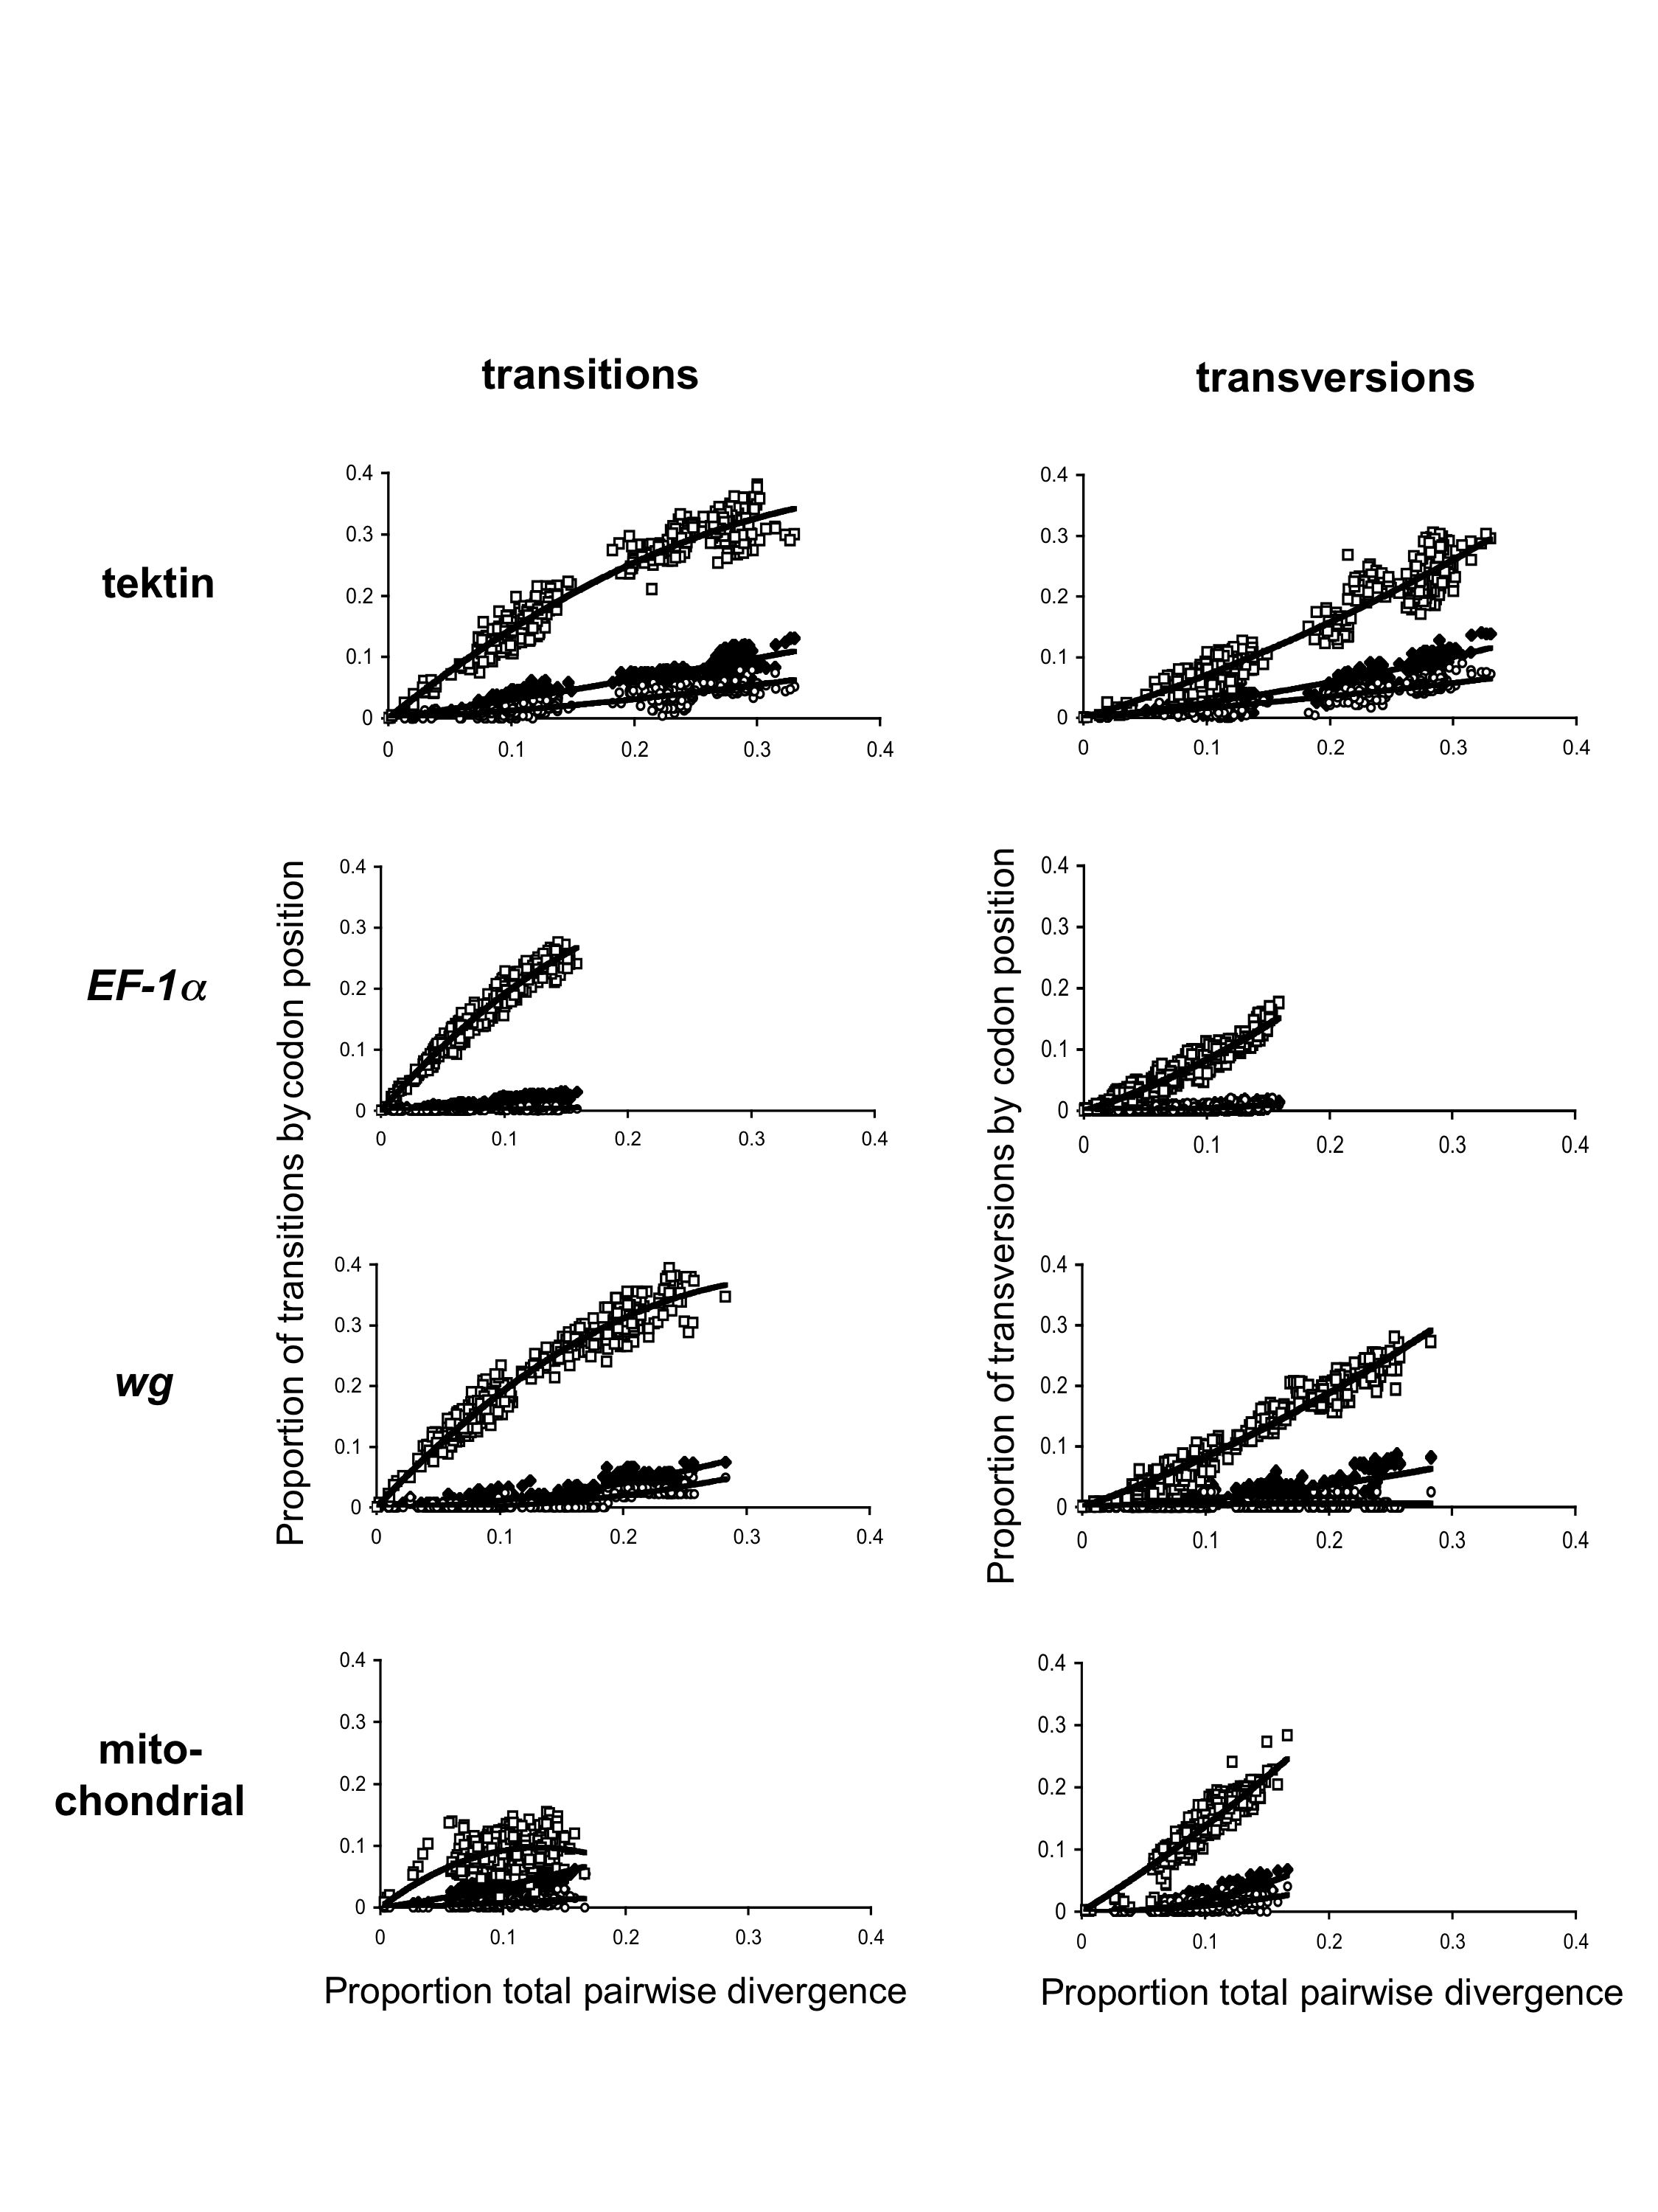
The different genes gave strong heterogeneous support for phylogenetic hypotheses: six wg and mitochondrial, 20 Ef1α and 22 Tektin branches were supported by both a Bayesian posterior probability greater than 0.70 and a bootstrap value greater than 70% in the parsimony analysis (Figs. 3-6.; and Table 3). There are cases of agreement between the phylogenetic hypotheses inferred by Bayesian methods across all genes, including monophyly of both Heliconiinae and Danainae, the Danainae internal topology, and the basal position of Hyposcada zarepha in the Hyposcada clade. There are also a number of examples where a particular topology is unique to a specific gene, for example, Ef1α fails to place the two Heliconius erato as sister taxa, and the mitochondrial data do not recover Elzunia as sister to Tithorea, or Velamysta as basal to Greta + Godyris. Additionally, there are cases of repeated discordance, such as the weakly supported position of Methona. Discordances among the individual gene trees are found at all phylogenetic levels, and within clades several different patterns of topological agreement can be observed. For example, within the Oleria clade, Tektin and wg place O. onega ssp nov as sister to one of the two O. onega janarilla individuals, whilst mitochondrial DNA and Ef1α group the two O. onega janarilla individuals; all genes placed O. assimilis as outside O. onega, but Ef1α and wg place O. gunilla and O. rubescens as a sister clade to the remaining Oleria taxa, whilst mitochondrial DNA and Tektin respectively support O. rubescens or O. gunilla as sister to all other Oleria.
Given these topological conflicts, we investigated which relationships emerged when the data were combined in a single analysis. Partitioned homogeneity tests indicated little evidence for heterogeneity (Ef1α:Tektin P = 0.91, Tektin:wg P = 0.94, Tektin:mitochondrial DNA P = 0.13, Ef1α:wg P = 0.98, Ef1α:mitochondrial DNA P = 0.45, wg:mitochondrial DNA P = 0.43), so all genes were concatenated for the overall analysis. The Bayesian total evidence analysis (Fig. 7) and maximum parsimony heuristic search (Fig. 8) inferred slightly different topologies; maximum parsimony placed Paititia, Athyrtis and Melinaea as the most basal clade, with Elzunia, Tithorea and Methona forming a clade that was sister to remaining Ithomiinae (the clade containing these last two clades had a bootstrap value of 72%). In contrast, Bayesian analyses placed Elzunia and Tithorea as a clade sister to remaining Ithomiinae, then Methona (posterior probability 0.56), then the Athyrtis, Paititia, Melinaea clade as sister to remaining Ithomiinae (posterior probability 0.56).
Overall, the total evidence Bayesian topology was most similar to the individual topologies inferred using Tektin and Ef1α. The Tektin and Ef1α topologies both differed from the total evidence topology in arrangements of the Paititia, Athyrtis and Melinaea clade, and placements of Oleria rubescens and Oleria gunilla. In addition, the Tektin topology differed from the total evidence topology at the intraspecific level (i.e. Hyposcada anchiala and Oleria onega), whilst Ef1α differed in the arrangement of the Velamysta, Greta, Godyris clade, position of Methona, and relationships between Heliconius species.
Mitochondrial DNA provides the strongest support for relationships between closely related taxa, as measured by Partitioned Bremer support values within the Hyposcada and Oleria clades. The Partitioned Bremer support analysis also revealed that Tektin most strongly supported the deeper nodes, indicating it contributed significantly to resolving positions of the most divergent taxa in the combined analysis.
Topologies inferred from Tektin protein (Fig. 9) and Tektin nucleotide data are in broad agreement, for example, by recovering the monophyly of the three nymphalid subfamilies, the basal positions of Elzunia, Tithorea and Methona within the Ithomiinae clade, and the derived position of the monophyletic Oleriini. Velamysta assumes the most discordant position, despite having lowest protein character differences to the taxa with which it clusters based on nucleotide data (14 with Greta and 12 with Godyris, compared to, for example, 21 with Napeogenes).
Discussion
Tektin proved easy to amplify from genomic DNA in all specimens tested, was amenable to direct sequencing, was easily aligned and exhibited a level of variation particularly appropriate for resolving phylogenetic relationships at the genus, tribe and subfamily levels.
Tektin products belong to a protein family, thus the potential for amplifying paralogs was of concern. However, the high nucleotide differentiation of Tektin paralogs makes them easily distinguishable, for example, uncorrected pairwise distances of A:B 52%, A:C 48% and B:C 52% were recovered for a 951 bp region of purple sea urchin Tektin which aligns without insertions and deletions (Genbank Accession numbers M97188, L21838 and U38523). As the pairwise distance values recovered in this study are all significantly lower than the distances observed between Tektin paralogs in other species, for example, within ithomiines (0 to 15.2%, mean 10.3%) and even between the silk moth outgroup and all other individuals (26.5 to 32.1%, mean 29.1%), it is highly likely that all our sequences are actually orthologous. In addition, phylogenetic analysis of Genbank Tektin sequences in human, mouse, sea urchin, fruit fly, silk moth and our ithomiine sequences (data not shown) cshows that Tektin sequences cluster together by paralog rather than by the species to which they belong. This clearly indicates that individual Tektin paralogs really are distinct enough to behave as single copy genes. Easily distinguishable paralogs have previously proven effective for phylogenetic analyses, including Ef1α and wg (Cho et al. 1995, Brower and De Salle 1998).
The mitochondrial and Tektin regions had the highest number of variable sites. However, when accounting for length differences, Tektin had the highest per-site variability. Despite its faster evolutionary rate, and the resultant concern that deep level comparisons using highly variable regions are often more confounded by the effects of saturation, Tektin proved to be more informative than mitochondrial DNA for the more distant comparisons. This is probably due to the biased nucleotide composition of the mitochondrial region (75.1%, compared to 59.9% in Tektin) hindering its deeper resolving power.
That the Tektin topology was in broad agreement to traditional classification and a recent cladogram inferred from morphology (Fig. 10, KRW & AVL Freitas, personal communication) strongly supports the utility of Tektin as a tool for successfully inferring relationships. The Tektin gene tree was most similar to that obtained from the Ef1α dataset, despite the differing placements of Velamysta, Greta and Godyris. Both Tektin and Ef1α topologies are well resolved, with most branches well supported. Mitochondrial DNA best differentiated closely related taxa within the Oleriini, but it failed to provide congruent support for intermediate depth internal branches and its placement of Napeogenes within Oleriini was clearly erroneous; both effects are probably due to the confounding effects of saturation, a by-product of the limited taxonomic sampling employed in this analysis. The topology generated from the wg data has more internal structure than the mitochondrial tree, but is also quite poorly resolved, in part because of short sequence length. These findings are based on our taxa of choice and may not have done justice to each gene, which have previously proven to be useful (Simon et al. 1994, Cho et al. 1995, Brower and De Salle 1998, Caterino et al. 2000). Our purpose was not to advocate or discourage general use of these “paradigm” genes, but to provide comparative evidence to enable future studies to select the combination of genes most appropriate for their level of phylogeny estimate.
After combining Tektin with COI and COII, wg and Ef1α regions, partitioned Bremer analyses demonstrated Tektin to be particularly effective at recovering the genus, tribe and subfamily relationships. The total evidence tree represents our preferred phylogenetic hypothesis, as is to be expected on theoretical grounds (DeSalle and Brower 1997), and also shows good agreement with the morphological tree (Fig. 10). Given the close correspondence between trees derived from Tektin alone and both combined evidence molecular and morphological trees, Tektin is arguably the most accurate single marker for inferring relationships among all taxa studied. We recommend future studies employ Tektin in conjunction with other genomic regions, in order to obtain robust and reliable phylogenetic hypotheses that best imply the organismal phylogeny. We believe Tektin to be a very useful addition to the molecular phylogenetic arsenal for studies of Lepidoptera. Our findings strongly endorse Tektin as a new candidate gene for phylogenetic and perhaps phylogeographical studies of other insect groups.
References

Ackery, P. R., De Jong, R., and R. I Vane-Wright. 1999. The butterflies: Hedyloidea, Hesperioidea and Papilionoidea. Pp. 263-300. In N. P. Kristensen (ed.), Lepidoptera, moths and butterflies. 1. Evolution, systematics and biogeography. Handbook of Zoology 4 (35), Lepidoptera. de Gruyter, Berlin.

Baker, R. H., and R. DeSalle. 1997. Multiple sources of character information and the phylogeny of Hawaiian Drosophilids. Syst. Biol. 46: 654-673.

Beltrán, M. S., C. D. Jiggins, V. Bull, M. Linares, J. Mallet, W. O. McMillan, and E. Bermingham. 2002. Phylogenetic discordance at the species boundary: comparative gene genealogies among rapidly radiating Heliconius butterflies. Mol. Biol. Evol. 19: 2176-2190.

Bensasson, D., D.-X. Zhang, D. L. Hartl, and G. M. Hewitt. 2001. Mitochondrial pseudogenes: evolution's misplaced witnesses. Trends Ecol. Evol. 16: 314-321.

Brower, A. V. Z. 1994. Phylogeny of Heliconius butterflies inferred from mitochondrial DNA sequences (Lepidoptera: Nymphalidae). Mol. Phylogenet. Evol. 3: 159-174.

Brower, A. V. Z. 2000. Phylogenetic relationships among the Nymphalidae (Lepidoptera) inferred from partial sequences of the wingless gene. Proc. R. Soc. Lond. B Biol. Sc. 267: 1201-1211.

Brower, A. V. Z., and R. De Salle. 1998. Patterns of mitochondrial vs. nuclear DNA sequence divergence in nymphalid butterflies: the utility of wingless as a source of characters for phylogenetic inference. Insect Mol. Biol. 7: 73-82.

Brower, A. V. Z., R. DeSalle, and A. Vogler. 1996. Gene trees, species trees, and systematics. A cladistic perspective. Annu. Rev. Ecol. Syst. 27: 423-450.

Brower, A. V. Z., and M. M. Jeansonne. 2004. Geographical populations and 'subspecies' of New World monarch butterflies (Nymphalidae) share a recent origin and are not phylogenetically distinct. Ann. Entomol. Soc. Am. 97: 519-523

Brower, A. V. Z., A. V. L. Freitas, M.-M. Lee, K. L. Silva Brandão, A. Whinnett and K. R. Willmott. 2005. Phylogenetic relationships among the Ithomiini (Lepidoptera: Nymphalidae) inferred from one mitochondrial and two nuclear gene regions. Syst. Entomol. (in press).

Caterino, M. S., S. Cho, and F. A. H. Sperling. 2000. The current state of insect molecular systematics: a thriving Tower of Babel. Annu. Rev. Entomol. 45: 1-54.

Chen, R., C. A. Perrone, L. A. Amos, and R. W. Linck. 1993. Tektin B1 from ciliary microtubules: primary structure as deduced from the cDNA sequence and comparison with Tektin A1. J. Cell Sci. 106: 909-918.

Cho, S., A. Mitchell, J. C. Regier, C. Mitter, R. W. Poole, T. P. Friedlander, and S. Zhao. 1995. A highly conserved nuclear gene for low-level phylogenetics: elongation factor 1-alpha recovers morphology-based tree for heliothine moths. Mol. Biol. Evol. 12: 650-656.

Cummings, M. P. 1994. Transmission patterns of eukaryotic transposable elements: arguments for and against horizontal transfer. Trends Ecol. Evol. 9: 141-145.

DeSalle, R., and A. V. Z. Brower. 1997. Process partitions, congruence and the independence of characters: inferring relationships among closely-related Hawaiian Drosophila from multiple gene regions. Syst. Biol. 46: 751-764.

Doyle, J. 1992. Gene trees and species trees: molecular systematics as one-character taxonomy. Syst. Bot. 17: 144-163.

Edwards, S. V., and P. Beerli. 2000. Perspective: Gene divergence, population divergence, and the variance in coalescence time in phylogeographic studies. Evolution 54: 1839-1854.

Farris, J. S., M. Källersjö, A. G. Kluge, and C. Bult. 1994. Testing significance of incongruence. Cladistics 10: 315-319.

Harrison, R. G. 1989. Animal mitochondrial DNA as a genetic marker in population and evolutionary biology. Trends Ecol. Evol. 4: 6-11.

Hudson, R. R., and M. Turelli. 2003. Stochasticity overrules the "three-times rule": genetic drift, genetic draft, and coalescence times for nuclear loci versus mitochondrial DNA. Evolution 57: 182-190.

Huelsenbeck, J. P., and F. Ronquist. 2001. MRBAYES: Bayesian inference of phylogenetic trees. Bioinformatics 17: 754-755.

Hurst, G. D. D., and F. M. Jiggins. 2005. Problems with mitochondrial DNA as a marker in population, phylogeographic, and phylogenetic studies: the effects of inherited symbionts. Proc. R. Soc. Lond. B Biol. Sc. (in press).

Kidwell, M. G. 1993. Lateral transfer in natural populations of eukaryotes. Annu. Rev. Genet. 27: 235-256.

Lamas, G. 2004. Nymphalidae. Ithomiinae, pp. 172-191. In G. Lamas (ed.), Checklist: Part 4A. Hesperioidea - Papilionoidea. In J. B. Heppner, (ed.), Atlas of Neotropical Lepidoptera. Volume 5A. Association for Tropical Lepidoptera, Scientific Publishers, Gainesville.

Linck, R. W. 1982. The structure of microtubules. Ann. N. Y. Acad. Sci. 383: 98-121.

Linck, R. W. 1990. Tektins and microtubules. Advances in Cell Biology 3: 35-65.

Linck, R. W., and G. L. Langevin. 1982. Structure and chemical composition of insoluble filamentous components of sperm flagella microtubules. J. Cell Sci. 58: 1-22.

Linck, R. W., L. A. Amos, and B. Amos. 1985. Localisation of Tektin filaments in microtubules of sea urchin sperm flagella by immunoelectron microscopy. J. Cell Biol. 100: 126-135.

Linck, R. W., D. F. Albertini, D. M. Kenney, and G. L. Langevin. 1982. Tektin filaments: chemically unique filaments of sperm flagellar microtubules. Prog. Clin. Biol. Res. 80: 127-132.

Machado, C. A., R. M. Kliman, J. A. Markert, and J. Hey. 2002. Inferring the history of speciation from multilocus DNA sequence data: the case of Drosophila pseudoobscura and its close relatives. Mol. Biol. Evol. 19: 472-488.

Maddison, W. P., and D. R. Maddison. 1997. MacClade: Analysis of phylogeny and character evolution. Sinauer Associated, Sunderland. Massachussets.

Mallarino, R., E. Bermingham, K. R. Willmott, A. Whinnett, C. D. Jiggins. 2005. Molecular systematics of the butterfly genus Ithomia (Lepidoptera: Ithomiinae): a composite phylogenetic hypothesis based on seven genes. Mol. Phylogenet. Evol. 34: 625-644.

Mallet, J. 2005. Hybridization as an invasion of the genome. Trends Ecol. Evol. 20 (5) 229-237.

Nei, M. 1987. Molecular Evolutionary Genetics. Columbia University Press, New York.

Neigel, J. E., and J. C. Avise. 1986. Phylogenetic relationships of mitochondrial DNA under various demographic models of speciation, pp. 515-534. In S. Karlin and E. Nevo (eds.), Evolutionary Processes and Theory. Academic Press, New York.

Nojima, D., R. W. Linck, and E. H. Egelman. 1995. At least one of the protofilaments in flagella microtubules is not composed of tubulin. Curr. Biol. 5: 158-167.

Norrander, J. M., L. A. Amos, and R. W. Linck. 1992. Primary structure of tekin A1: Comparison with intermediate filament proteins and a model for its association with tubulin. Proc. Natl. Acad. Sci. U. S. A. 89: 8567-8571.

Norrander, J. M., C. A. Perrone, L. A. Amos, and R. W. Linck. 1996. Structural Comparison of Tektins and Evidence for Their Determination of Complex Spacings in Flagellar Microtubules. J. Mol. Biol. 257: 385-397.

Ota, A., T. Kusakabe, Y. Sugimoto, M. Takahashi, Y. Nakajima, Y. Kawaguchi, and K. Koga. 2002. Cloning and characterisation of testis-specific Tektin in Bombyx mori. Comp. Biochem. Physiol. Part B Biochem. Mol. Biol. 133: 371-382.

Pamilo, P., and M. Nei. 1988. Relationships between gene trees and species trees. Mol. Biol. Evol. 5: 568-583.

Philippe, H., and C. J. Douady. 2003. Horizontal gene transfer and phylogenetics. Curr. Opin. Microbiol. 6: 498-505.

Pirner, M. A., and R. W. Linck. 1994. Tektins are heterodimeric polymers in flagellas microtubules with axial periodicities matching the tubulin lattice. J. Biol. Chem. 269: 31800-31806.

Rokas, A., B. L. Williams, N. King, and S. B. Carroll. 2003. Genome-scale approaches to resolving incongruence in molecular phylogenies. Nature (Lond.) 425: 798-804.

Simon, C., F. Frati, A. Beckenbach, B. Crespi, H. Liu, and P. Flook. 1994. Evolution, weighting, and phylogenetic usefulness of mitochondrial genes with a compilation of conserved PCR primers. Ann. Entomol. Soc. Am. 87: 651-701.

Sorenson, M. D. 1999. TreeRot, version 2. Boston University, Boston, MA.

Swofford, D. L. 2000. PAUP*: Phylogenetic Analysis Using Parsimony (* and Other Methods). Sinauer Associates, Sunderland, Mass.

Syvanen, M. 1994. Horizontal gene transfer: evidence and possible consequences. Ann. Rev. Genet. 28: 237-261.

Takahata, N., and M. Nei. 1985. Gene genealogy and variance of interpopulational nucleotide differences. Genetics. 110: 325-344.

Fig. 3. Phylogenetic hypothesis based on Tektin nucleotide data. Tree topology is consensus of the last 9,000 trees inferred using Bayesian methods. Bayesian probabilities above 0.70 (above branch) and parsimony bootstrap support values higher than 70% (below branch) are given.

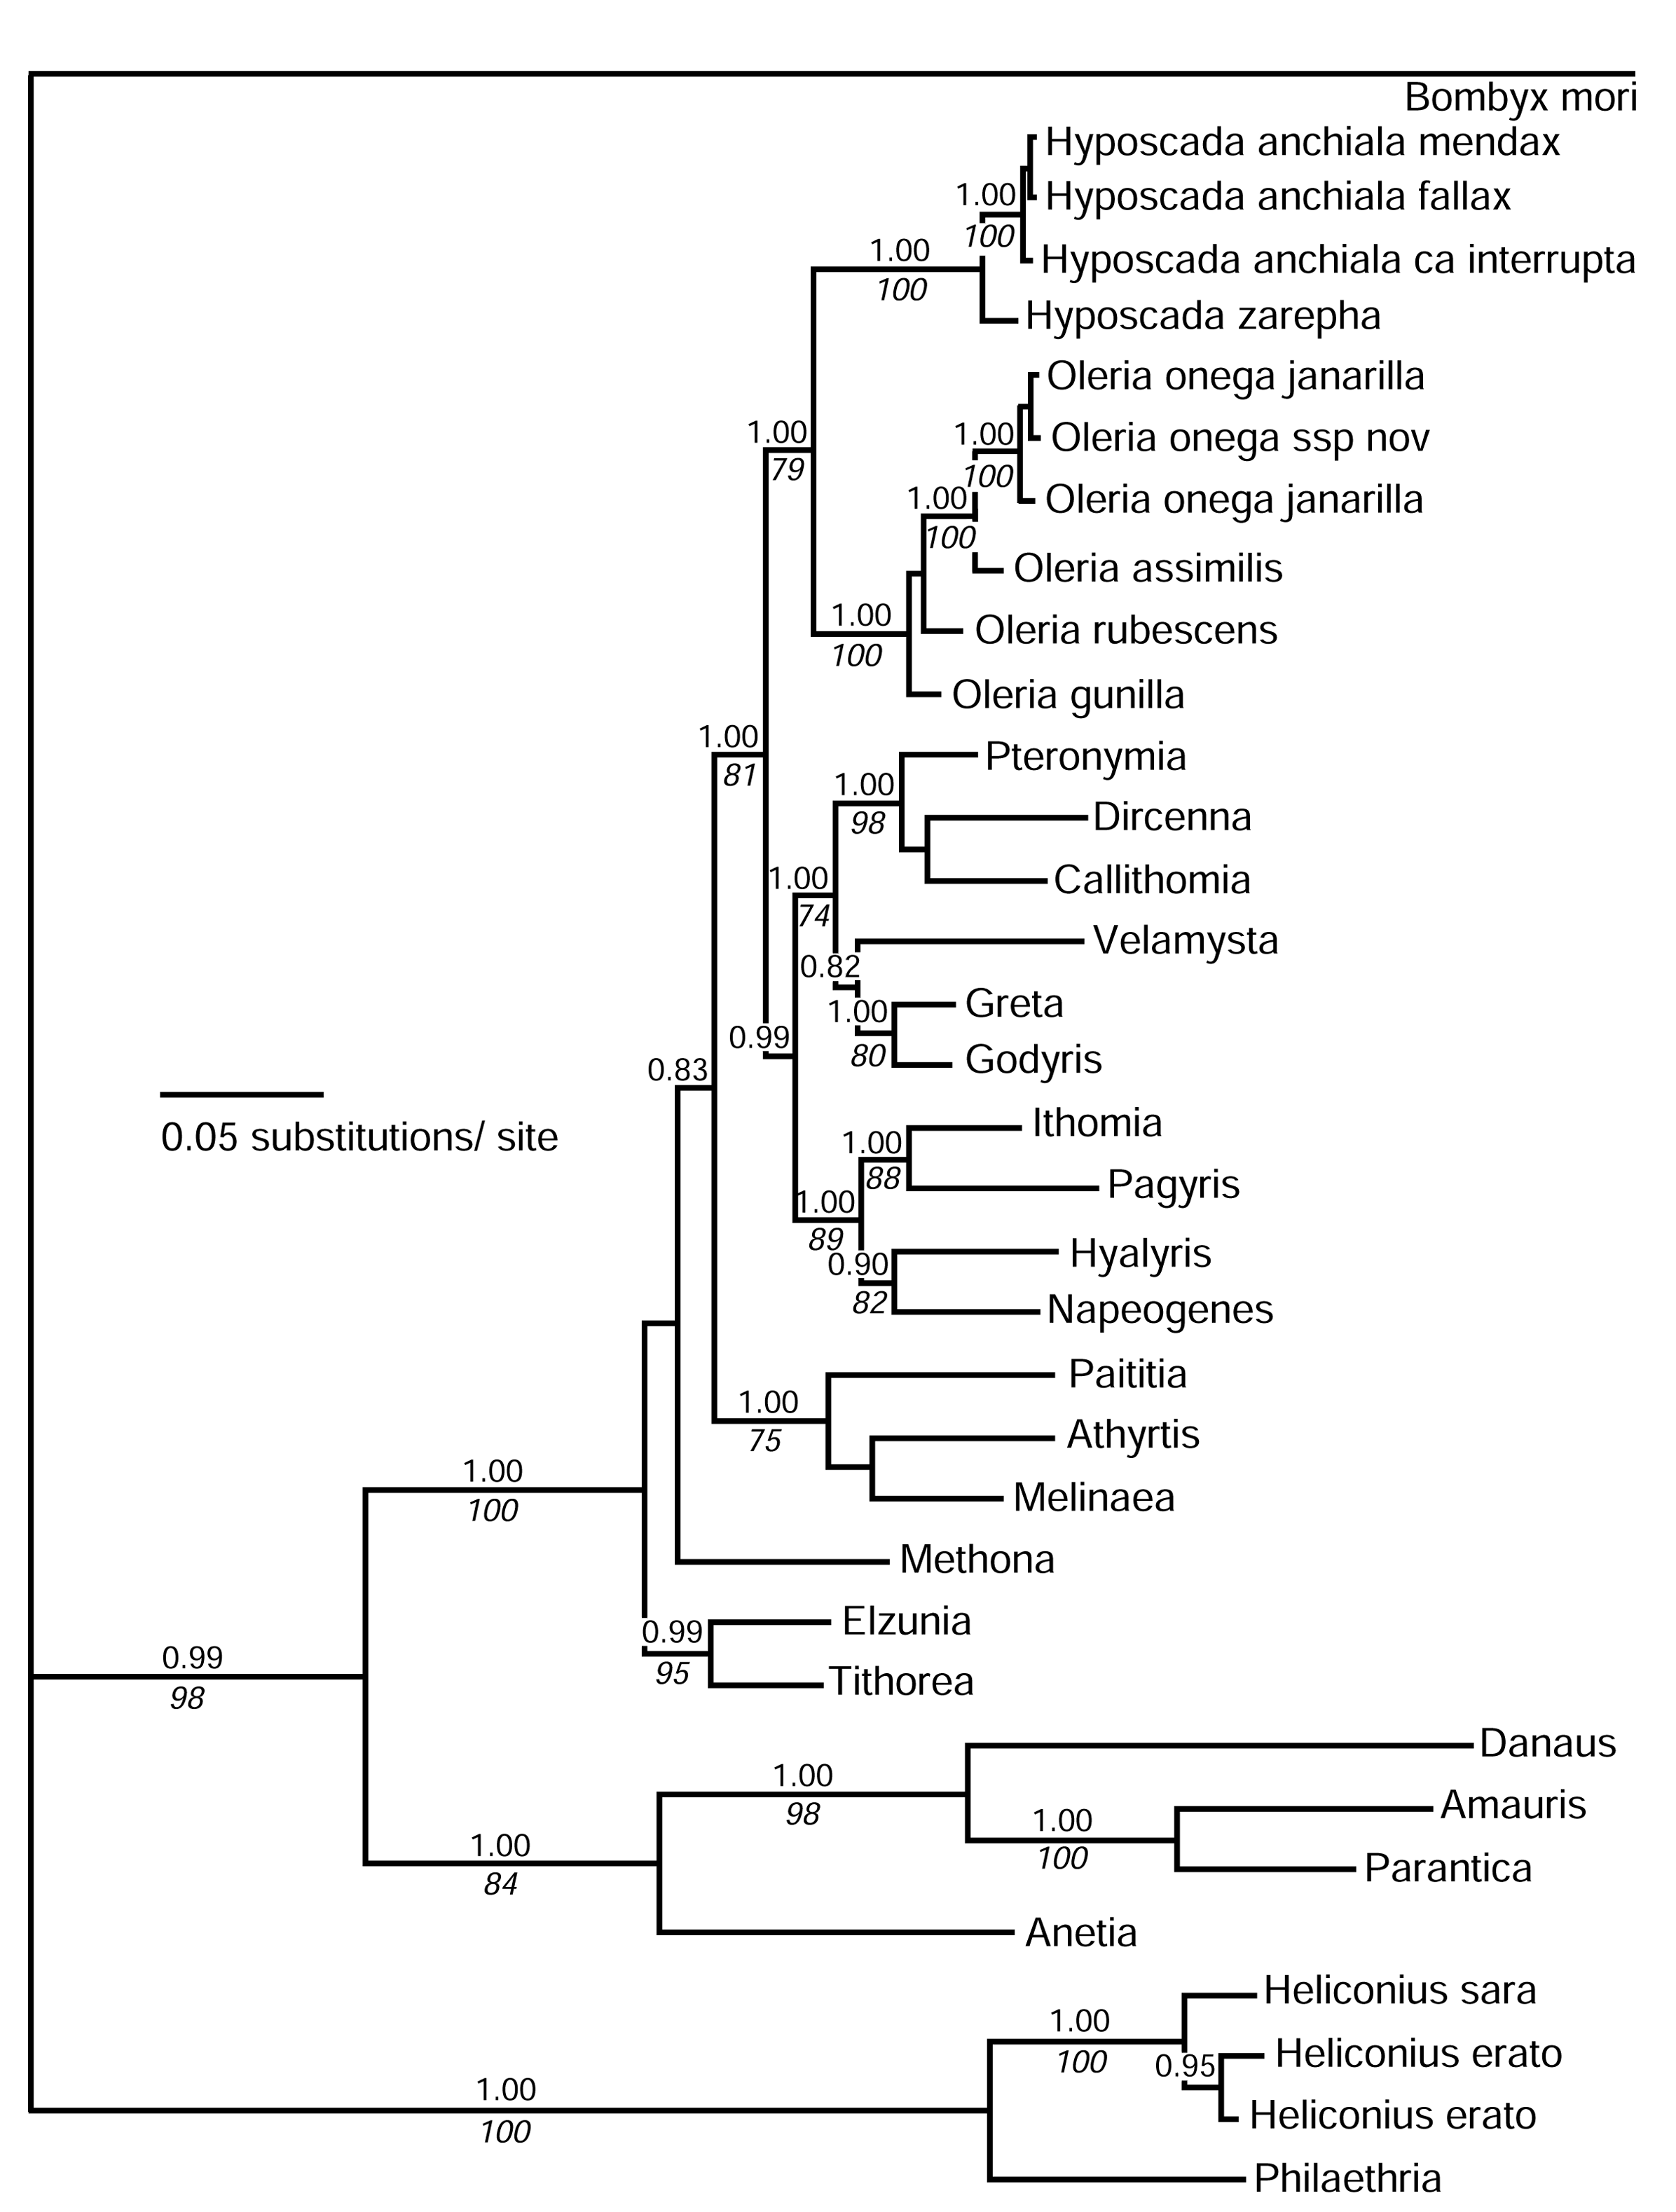

Fig. 4. Phylogenetic hypothesis based on wg nucleotide data. Tree topology is consensus of the last 9,000 trees inferred using Bayesian methods. Bayesian probabilities above 0.70 (above branch) and parsimony bootstrap support values higher than 70% (below branch) are given.

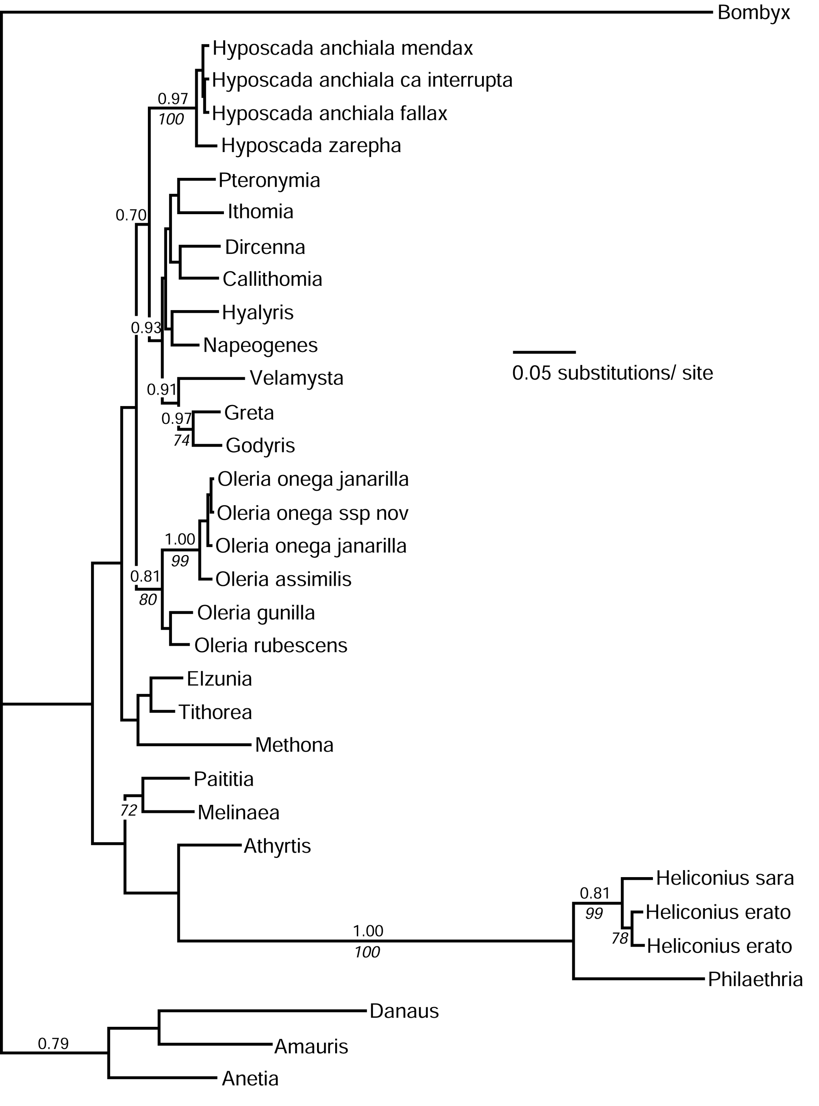

Fig. 5. Phylogenetic hypothesis based on Ef1α nucleotide data. Tree topology is consensus of the last 9,000 trees inferred using Bayesian methods. Bayesian probabilities above 0.70 (above branch) and parsimony bootstrap support values higher than 70% (below branch) are given.

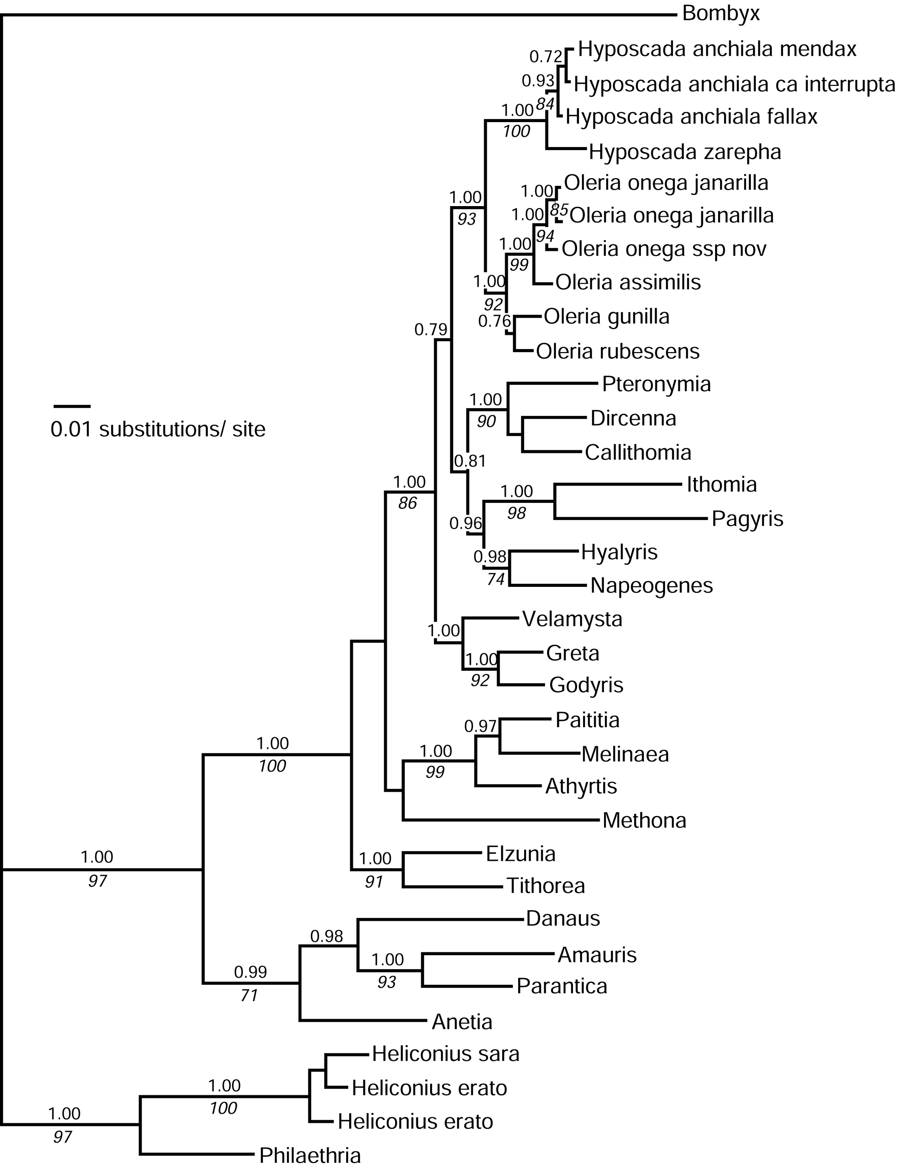

Fig. 6. Phylogenetic hypothesis based on mitochondrial nucleotide data. Tree topology is consensus of the last 9,000 trees inferred using Bayesian methods. Bayesian probabilities above 0.70 (above branch) and parsimony bootstrap support values higher than 70% (below branch) are given.

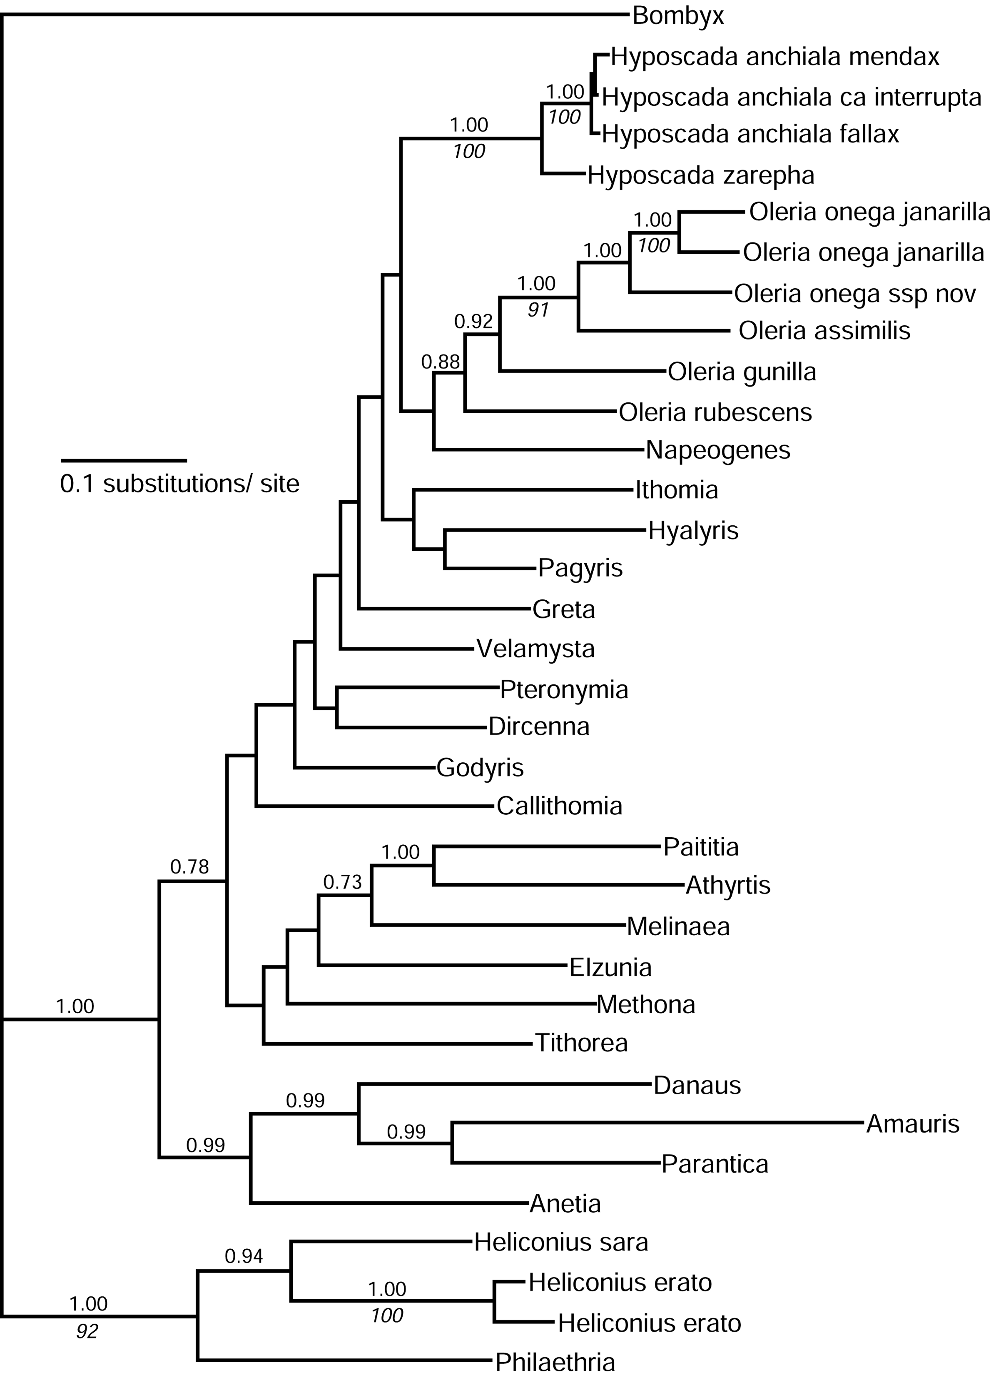

Fig. 7. Total evidence phylogenetic hypothesis. Tree topology is consensus of last 9,000 trees inferred using Bayesian methods. Bayesian probabilities above 0.70 (above branch) and parsimony bootstrap support values higher than 70% (below branch) are given.

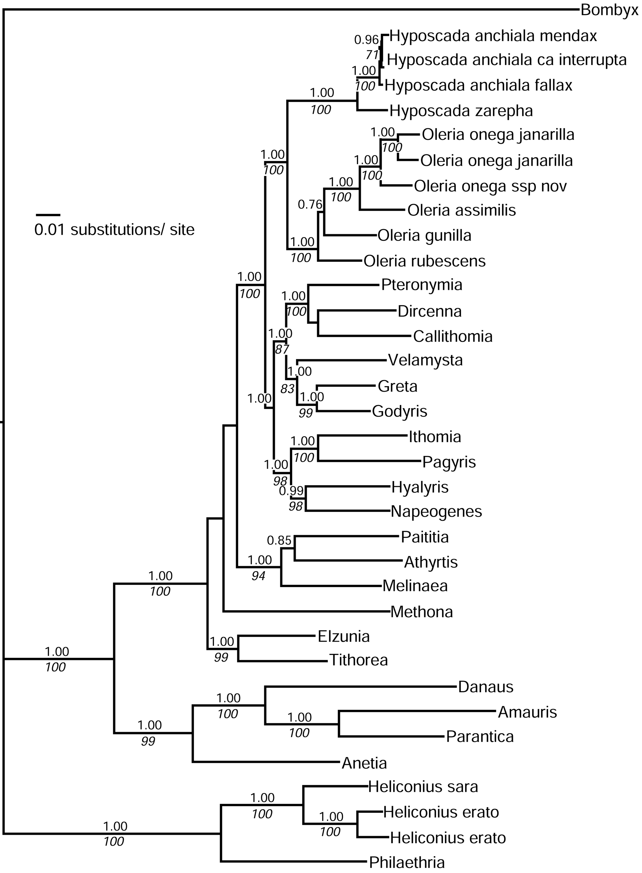

Fig. 8. Total evidence phylogenetic hypothesis. Tree topology was inferred with maximum parsimony. Partitioned Bremer support values are given above branches (Tektin/ Ef1α/ wg/ mitochondrial).

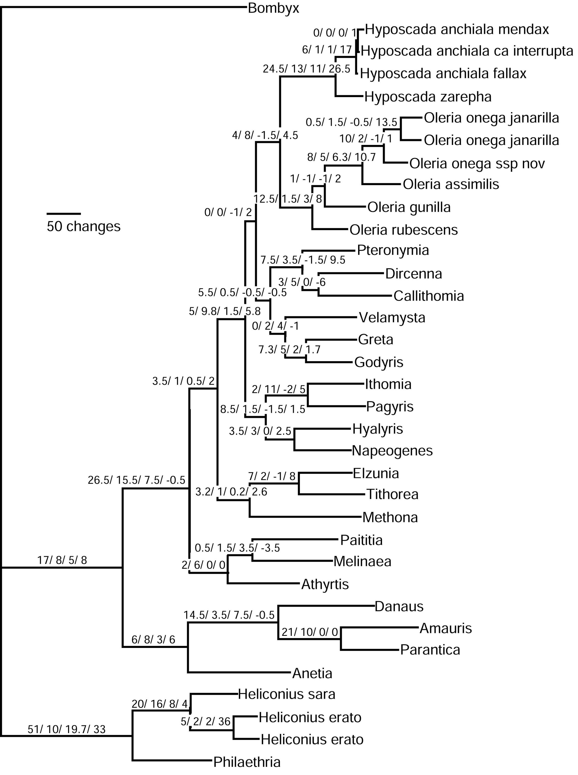
Fig. 9. Phylogenetic hypothesis based on Tektin amino acid data, inferred with neighbour joining. Neighbour joining bootstrap support values are given below branches.

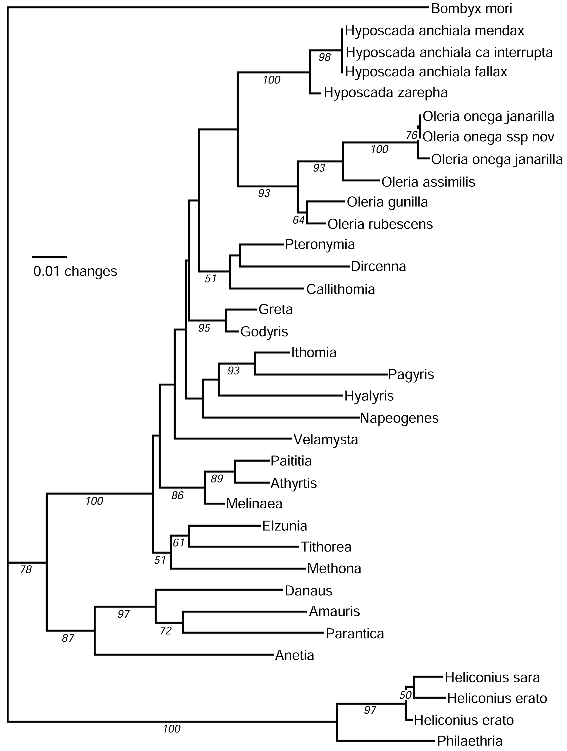
Fig. 10. Most parsimonious tree inferred from combined morphological and ecological data after successive approximations character weighting (KRW & AVL Freitas, personal communication).

